|  |  |  |
| --- | --- | --- |
|  | **FRONTIER LAW COLLEGE**  **AFFILIATED WITH UNIVERSITY OF PESHAWAR (1990)**  **PAJAGGI ROAD, PESHAWAR CITY**  **Time Table**  **Semester IX Year 2025** |  |

|  |  |  |  |  |
| --- | --- | --- | --- | --- |
| DAY/TIME | 9:00am to 9:45am | 9:45am to 10:30am | 10:30am to 10:45am | 10:45am to 11:30am |
| Monday | Moot Cases & Legal Ethics | Moot Cases & Legal Ethics | **B** | Research Methods |
| Tuesday | Minor Acts | Minor Acts | **R** | Consumer Protection Law |
| Wednesday | Labour Law | Labour Law | **E** | Minor Acts |
| Thursday | Consumer Protection Law | Consumer Protection Law | **A**  **K** | Research Methods |
|  |  |  |  |  |

Labour Law …..….……………………….……….….…. Pro.Dr. Abdul Manan (AM)

Minor Acts ……………………………….…......…….… Syed Shahid Hussain Bukhari (SSH)

Moot Cases & Legal Ethics……………................…Muhammad Suleman (MS)

Research Methods ………………….…………..…… Hfsa Iqbal (HI)

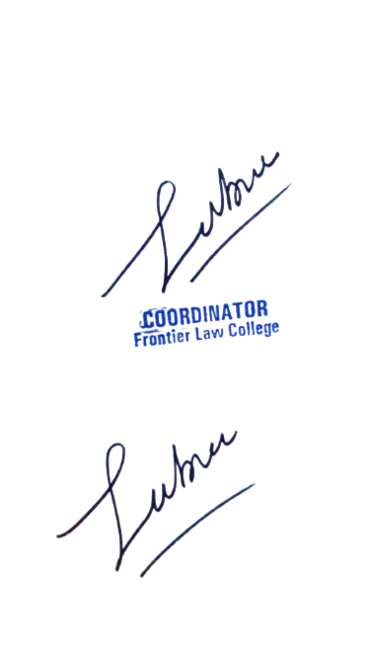Consumer Protection Law …..…………………… Ayesha Zeenat (AZ)



**Academic Coordinator**