|  |  |  |
| --- | --- | --- |
|  | **FRONTIER LAW COLLEGE**  **AFFILIATED WITH UNIVERSITY OF PESHAWAR (1990)**  **PAJAGGI ROAD, PESHAWAR CITY**  **Time Table**  **Semester III Year 2025** |  |

|  |  |  |  |  |
| --- | --- | --- | --- | --- |
| DAY/TIME | 9:00am to 9:45am | 9:45am to 10:30am | 10:30am to 10:45am | 10:45am to 11:30am |
| Monday | English-III | English-III | **B** | Logic & Reasoning |
| Tuesday | Law of Torts-II | Law of Torts-II | **R** | UK-Constitution I |
| Wednesday | Islamic Jurisprudence-I | Islamic Jurisprudence-I | **E** | Law of Torts-II |
| Thursday | Law of Contract | Law of Contract | **A** | Islamic Jurisprudence-I |
| Friday | Logic & Reasoning | Logic & Reasoning | **K** | UK-Constitution I |

Logic & Reasoning….……………………….……Muhammad Suleman(MS)

Islamic Jurisprudence-I…………………….…Mehwaish Parveez(MP)

Law of Contract…………………….………….…Rukhsar Arbab(RA)

UK-Constitution-I…………………………...…..Ayesha khan(AK)

Law of Torts-II…………………………….……..Ayesha Zeenat(AZ)

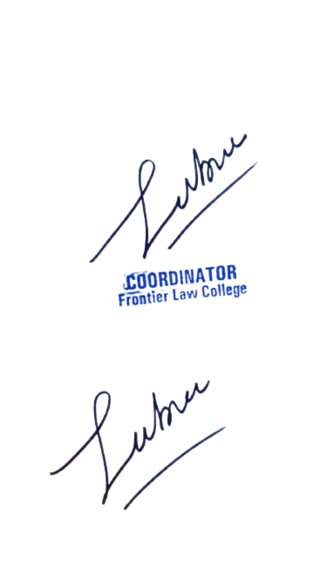English –III………………………………….......…Hamza Bin Anees (HBA)



**Academic Coordinator**